Marginal Effects in Quadratic Regression Models:

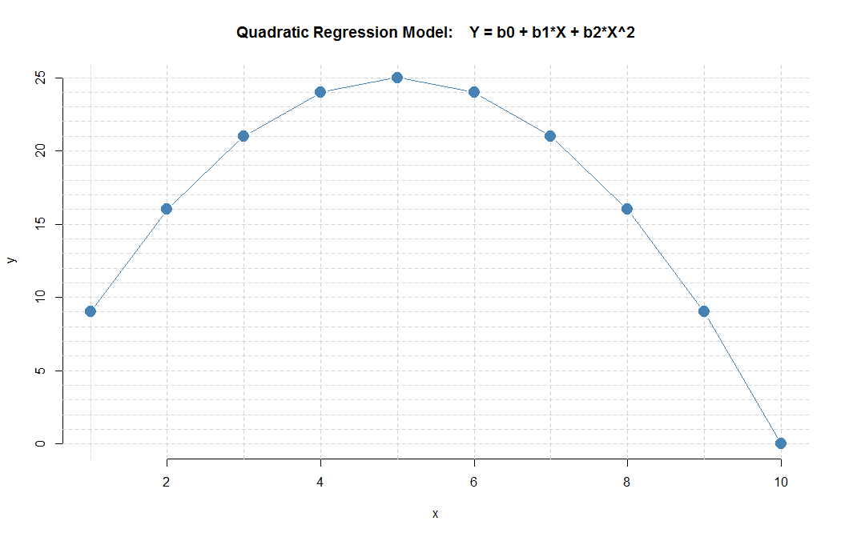

**x xsq yhat**

1 1 9

2 4 16

3 9 21

4 16 24

5 25 25

6 36 24

7 49 21

8 64 16

9 81 9

10 100 0

The regression model in this example has the following parameters:

$$Y = 0 + 10*X - 1*X^{2}$$

Question: what is the marginal effect (change in Y associated with one-unit change in X) at the given points:

1. What is the marginal effect at X=1? What is the “slope” between X=1 and X=2?
2. What is the marginal effect at X=5?
3. What is the marginal effect at X=9?